**Team Members:**

Ahmed Kandil

Ahmed Khaled Abdelmaksoud

Amr Saad

**Problem Statement:**

Digitalization of data for Garden, turning it into a smart one.

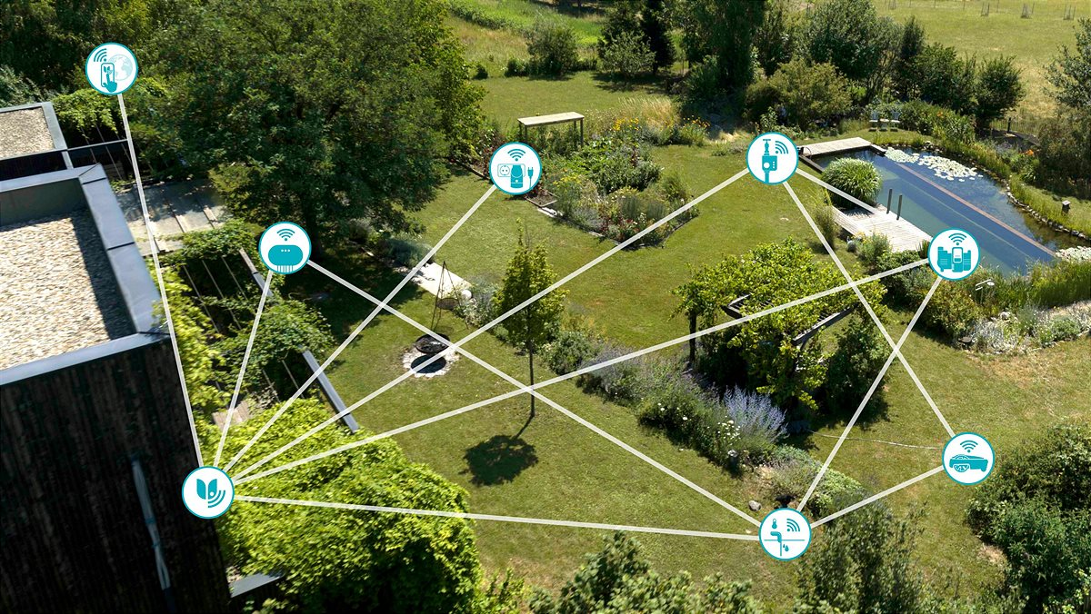

**Solution:**

1. Communication Protocol:

We used : MQTT and HTTP protocols

* We used MQTT to connect between the device and the RP, we have four topics (temperature, money, capacity, fire).

* + Temperature is made for transferring data of temperature of the garden
  + Money is made for transferring data of money collected till the current time stamp
  + Capacity is made for transferring data of the current capacity of people in the garden
  + Fire is made for indicating whether there is a fire in the garden or it’s safe
* We used HTTPs to transfer the collected data to the dashboard (Blynk)

1. Version control:
   * We divided our work into branches, continuing on the work of the last time.
   * We added some new features on the project from the last time, like smoke sensor for detection of fire in the garden, making a branch for thus feature, then merging this branch to the main branch.
   * The version on the main branch is the more stable one.
2. IoT platform Integration (Blynk):
   * We started to create a new template for our project, then we added the device and started to make data streams.

* Then, start to design our dashboard and add the labels for each topic: (temperature, money, capacity, fire detection). and connecting with their data streams.
* We gain the token from BLYNK and added to the code to make the authentication key and defined our virtual pins.

1. IoT Components:
   * Sensors:
     1. Smoke sensor 🡪 Detection whether there’s a fire in the garden or not.
     2. Ultrasonic sensor🡪 Detection of people entering the garden and exiting from the garden
     3. LDR 🡪Detection of the light when the day is ended and getting into night to give signal to the bulbs to turn on
     4. DHT🡪 Detection of temperature and humidity to turn fans and water pumps on when the temperature gets hot

* Actuators:
  + Leds: Indications for signals coming from sensors
  + Buzzer: Indications for the Smoke sensor when there’s a fire in the garden

